March 2023
Dear Pastor and Friends,
The security situation in the north of Togo had led to population displacements. The incursion of terrorists with multiple attacks has increased fear among the population. Let us pray for armed forces which are fighting against these terrorists.
Thanks God, in spite the fear of Terrorists we baptized twenty-five (25) people and among this people one blind women.

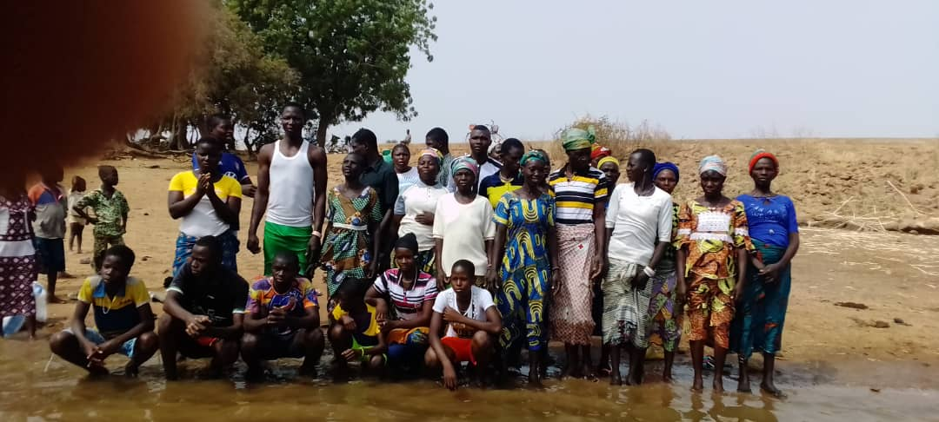
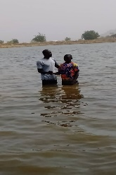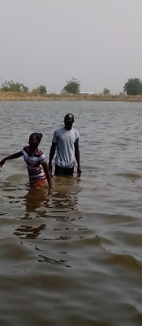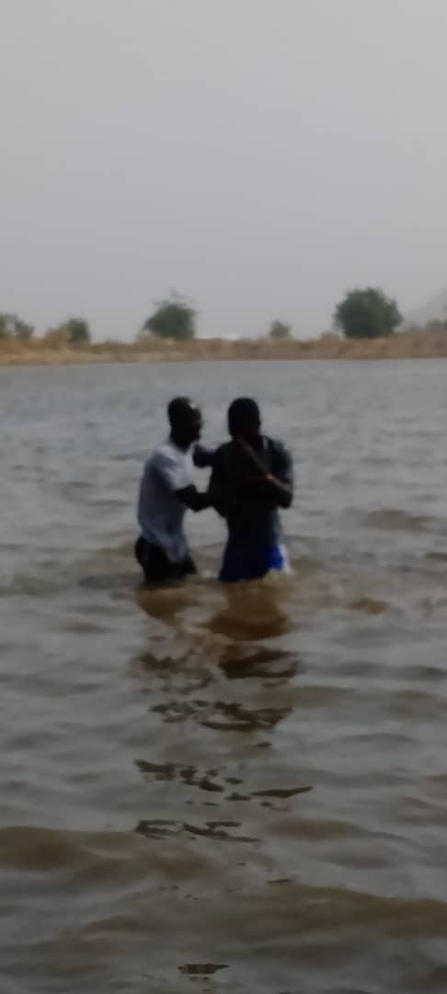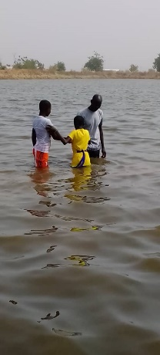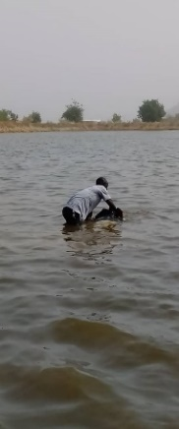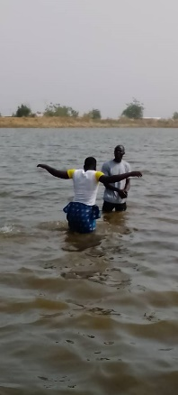

Here the picture of the blind lady that was baptized.
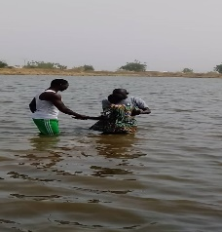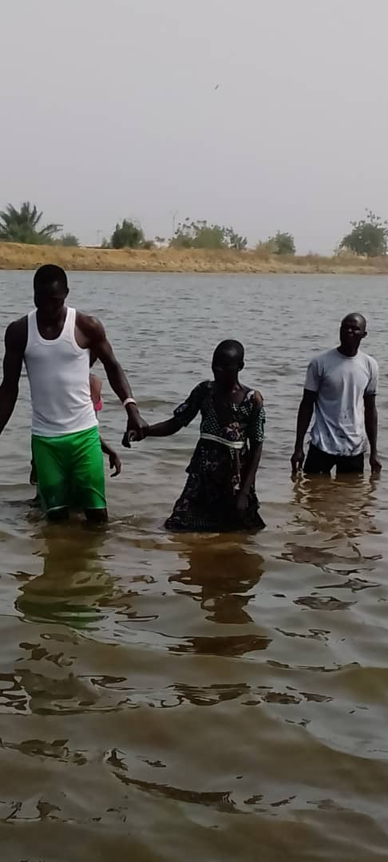

In Burkina Faso, in spite the insecurity in Burkina Faso, my team keeps going what the Lord calls us to preach the Word of God. We hold open Evangelism on Village of Bagrouatenga with 1500 population where 45 precious souls were saved( 15 men and 30 women). Now we have to build a shelter for them that would cost around $4,600.

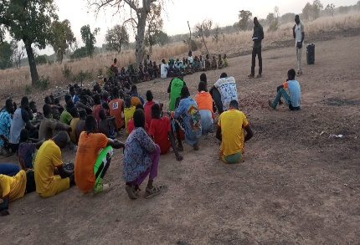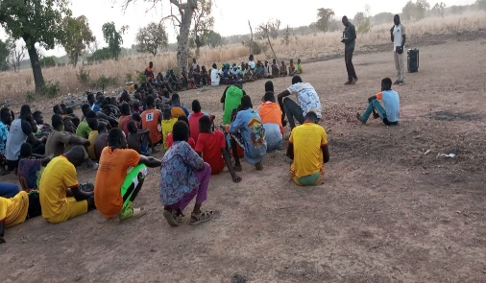

We hold the first service worship this Sunday February 26, 2023, under Mangoes threes and a attendance was ok.

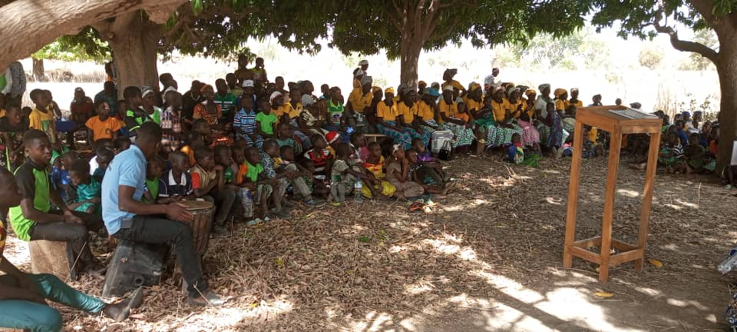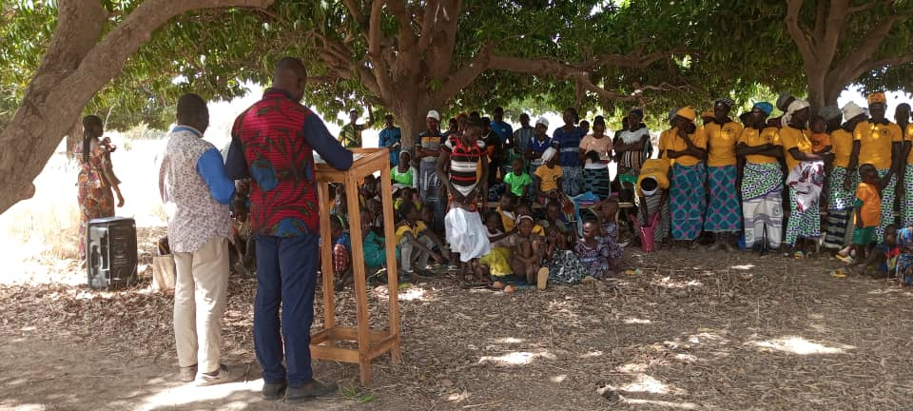
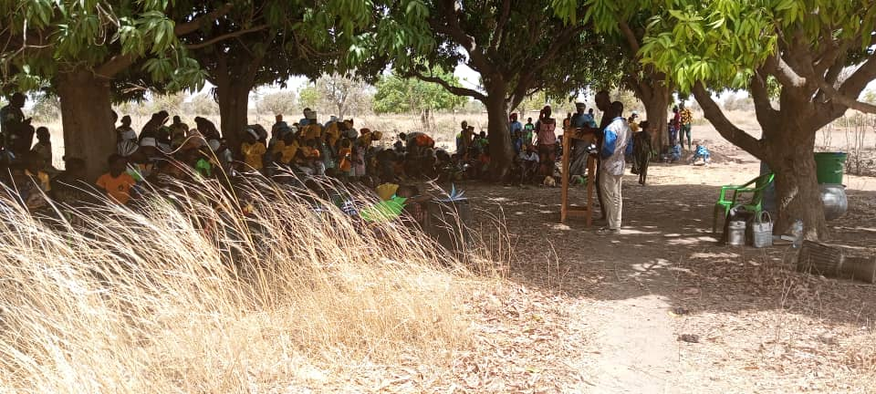

We are still looking for $1,440 to pay (tuition fees, books, transport, and foods) for three of our preacher boys to finish their last school year of training.
Keep praying that the Lord would provide the fund of $50,000( received so far $4,000) that we need to buy that propriety. We need a miracle.

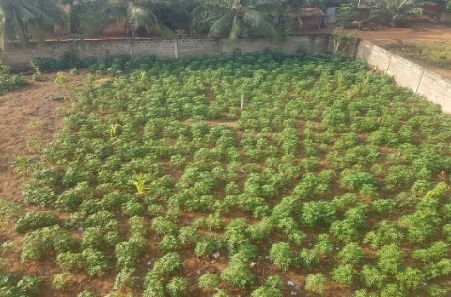

Serving Him Together,
The Agbodo Family

Missionaries to Togo, West Africa

